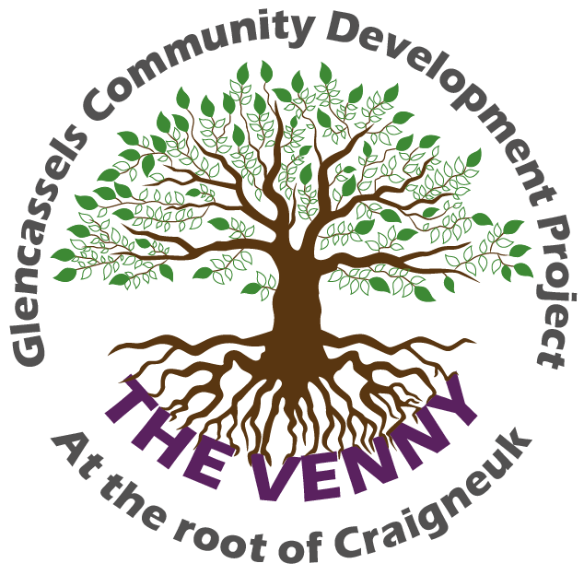 | 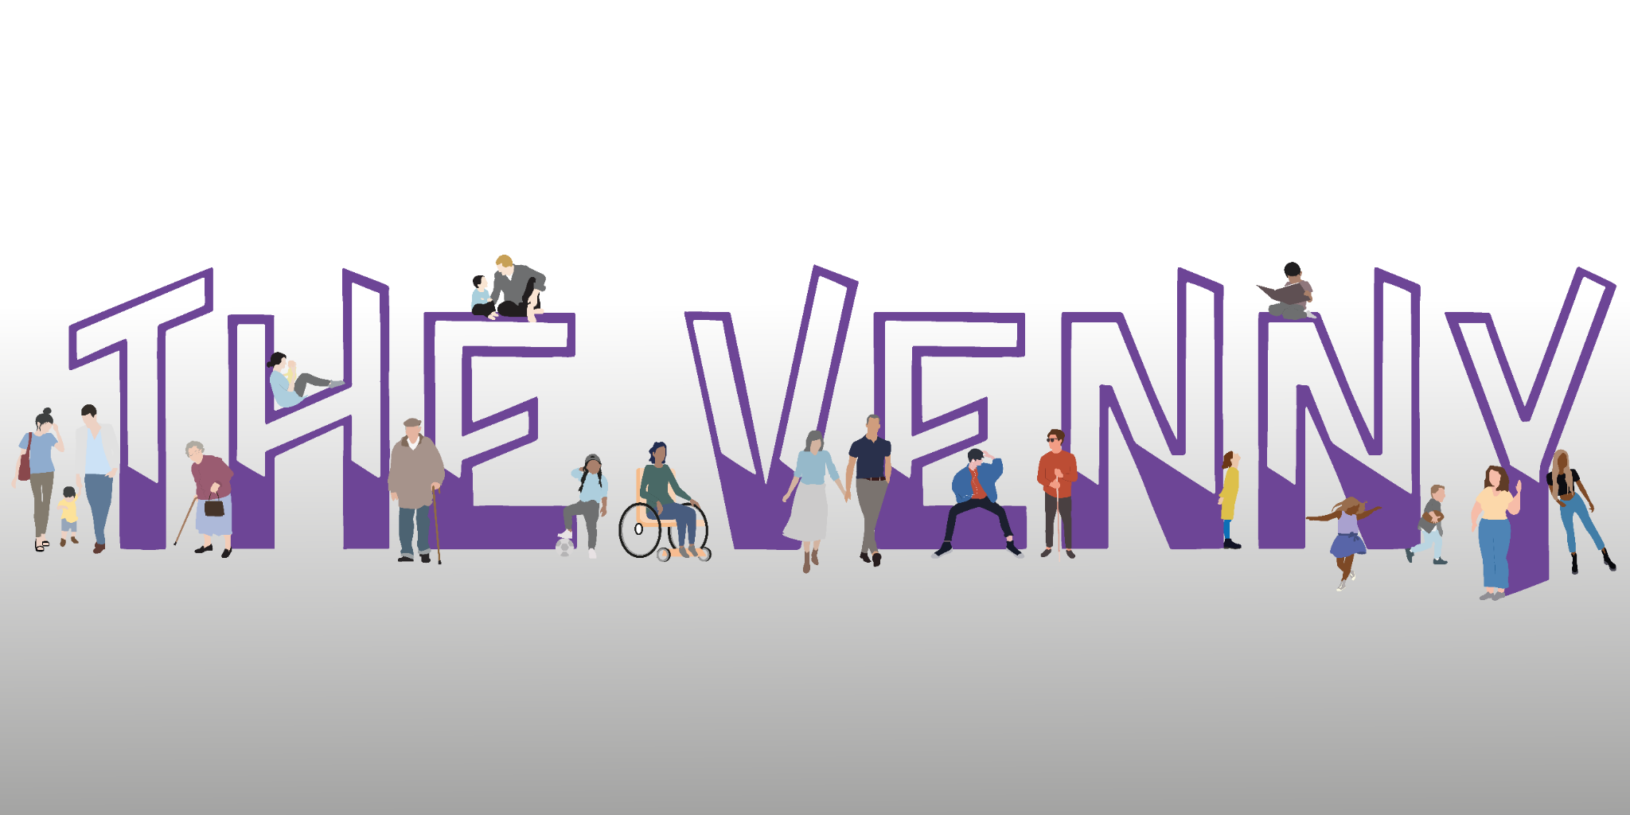
SESSIONAL YOUTH WORKER
Recruitment Pack
PAY | HOURS | LOCATION | CONTRACT
£13.45 per hour | 6–9 hours per week | The Venny, Craigneuk | Part-time • 42 weeks

Could you make a difference at The Venny?
We are looking for a confident, approachable and enthusiastic Sessional Youth Worker to join our small team and help deliver after-school and evening youth clubs for children and young people in our community.
This is not just about supervising activities. We want someone who can build genuine relationships with young people, listen to what matters to them, bring ideas and initiative, and help create opportunities that young people genuinely want to be part of.

About The Venny
Glencassels Community Development Project is a well-established community organisation based in Craigneuk. Our neighbourhood centre, known locally as The Venny, provides recreational, social and educational activities for children, young people and adults. We want The Venny to be somewhere young people feel welcomed, valued, safe and able to be themselves.

The role
- Build positive and trusting relationships with children and young people.
- Help plan and deliver fun, engaging and meaningful youth work sessions.
- Encourage young people to participate, share their ideas and try new things.
- Support young people to develop confidence, friendships and new skills.
- Help create a safe, welcoming and inclusive environment.
- Support trips, events and wider opportunities where appropriate.
- Work positively as part of our small staff and volunteer team.
- Follow safeguarding, health and safety and organisational procedures.

Who we are looking for
Experience of working or volunteering with children or young people is required. This does not need to come from a traditional youth work role. Relevant experience could include youth work, education, community work, sports coaching, childcare, mentoring, support work or a similar setting.
We are particularly interested in people who:
- Can engage confidently with children and young people and build positive relationships.
- Bring enthusiasm, ideas and initiative rather than waiting to be directed at every stage.
- Understand that good youth work starts with listening to young people and responding to their interests and needs.
- Are reliable, approachable and able to work well as part of a team.
- Understand the importance of safeguarding, professional boundaries and creating safe spaces.
- Share our values of inclusion, equality and respect.
- Can commit reliably to regular after-school/evening sessions during the school term.
You do not need to have followed a traditional youth work career path. We are interested in your experience, your values and what you could bring to our young people.

What we offer
- £13.45 per hour, paid at the Real Living Wage rate.
- A friendly and supportive small-team environment.
- Training and development opportunities.
- The chance to help shape activities and opportunities for local young people.
- Experience within an established community organisation.
- A role that may fit well alongside another part-time job, study or existing work with children and young people.

Our commitment as an employer
Glencassels Community Development Project is proud to have achieved the North Lanarkshire Employer Charter Bronze Award, recognising our commitment to building a positive and supportive workforce.
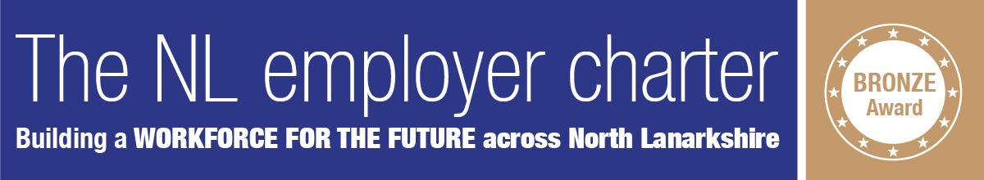

How to apply
Please complete THE VENNY APPLICATION FORM -. We want to hear about your relevant experience, why you would like to work with our young people and what you could bring to the role.
Application method | THE VENNY APPLICATION FORM
Return by email | glencasselscommunitydev@gmail.com
Closing date | 25th September 2026
CVs | CVs will not be accepted in place of the application form

Before you apply
Please make sure you are able to commit to the regular session times required for the post. The successful candidate will be required to complete the organisation's safer recruitment and pre-employment checks appropriate to the role.

Selection
Applications will be shortlisted against the requirements of the role. Shortlisted candidates will be invited to meet with us and discuss their experience, approach to working with young people and what they could bring to The Venny.
We want people who believe they can make a positive difference to young people in our community.
Glencassels Community Development Project • The Venny • Craigneuk, Wishaw
Email: glencasselscommunitydev@gmail.com

